Docker file, index file ,Docker compose file and volume is created

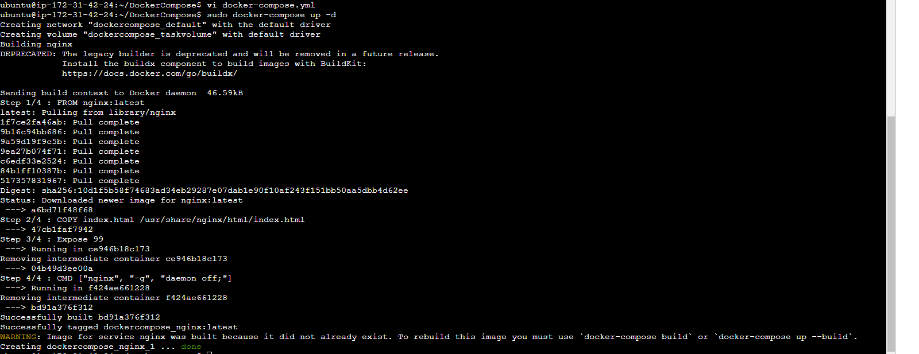

Image got created

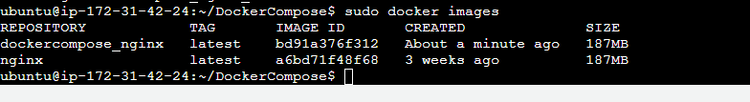

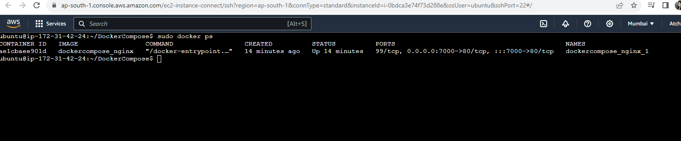

Application is Running

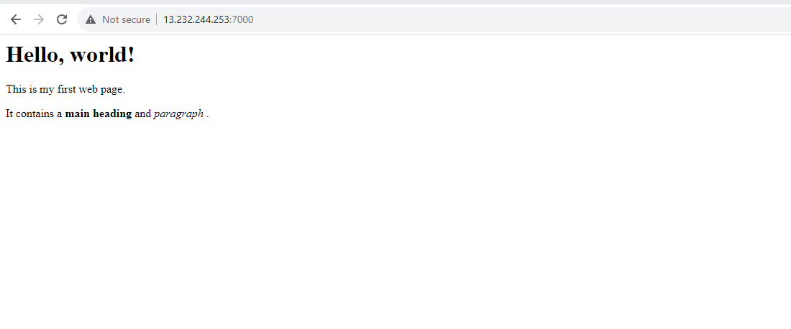

Docker image pushed to Docker hub

